**Web application development**

**Professor: Dr. Muhammad Iqbal**

**CA 3**

**Rich internet application**

**by**

**Krunoslav Bubanj**

**x18110274**

We have been tasked to develop a rich internet application which will incorporate all elements of the modern rich internet application (RIA) to showcase the inevitable transition from the standard web pages. The RIA should contain the following:

- Client side scripting

- Server side scripting

- Data manipulation

Based on the given description, I have developed a RIA using HTML, CSS, Javascript, JSON, Google map API and PHP to fulfil all requirements stated above.

The RIA has a function to display the capital city of every country in the world and show the interactive map of the city on the side.

The end user can type the name of the country in the input field and based on the letters typed, he or she will be presented with a suggested list of countries starting with what was typed. Upon selecting one of them, user clicks on a “Go” button which then populates the field below showing the capital city of the selected country and the map of that city on the side. The user can also click on the “Documentation” button which will show the functions, programming languages, processes, location and the author of all the code used to complete this project. 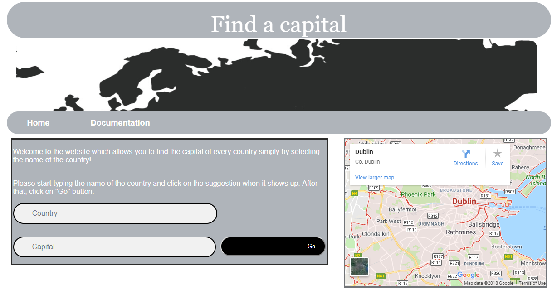

Short breakdown of the functionality

Javascript :

Used for the displaying suggestions to the user, processing the form and displaying the results on the index page

HTML:

Used for page markup

JSON:

Used to store the information about the functionality in the “Documentation” page

PHP:

Used to display the data from a JSON file to the end user

CSS:

Used to enhance graphic interface for the user

Google API:

Used to display the location on the embedded map

Starting from the beginning, the HTML markup was used to create a DOM which determined the basic look and the functionality of the index page.

In the “head” section of the website, the CSS style sheet was referenced as well as the document’s source. Underneath under “meta” tag, we have encoding declaration below which we can find Javascript declaration and source as well as title. In the body section, the CSS id is included to apply the CSS look to the “div” segment. Underneath, we have a “header” for displaying a title and a “canvas” tag for slideshow below which we can find 2 buttons – for home and documentation page. Down below, we can find “article” and “section” tags within which we can find a paragraphs with instructions. Below the paragraphs, “form” tag is indicating the begging of the form which will be sent for validation after the input fields have been filled. After the fields have been filled out, the is a submit button with a title “Go” next to it which will submit the form to a javascript function which will return the result in the input field below and also display the map of the capital city of the selected country on the embedded Google map on the right hand side of the screen.